***User Manual***

1. Description

This game requires 2 players. Before playing, a password (SW9) need to be entered to give players full access to the full board and using push button (Key3) to enter one bit at a time. After that, each player will take turn to input a single (4 bits) number. The first player will start out with the switches SW0 – SW3 (for input B, SW0 is LSB) and SW14 – SW17 (for input A, SW14 is the LSB). After the player “A” input the first number and press the enter button (same), the number will show up in the 7 segments display HEX6. After this, it is player “B”s turn. The player B will input another number using switches SW0 – SW3. After the second player input the number and press the enter button (same), the number will show up in the 7 segments display HEX3. Each time the player input a number, the sum of both number from player A and player B will show up in 7 segments display HEX5. All the number show up in the 7 segments display will be in base 16. Upon pressing Reset button (Key0), the display will clear to zeros.

1. User Manual in Pictures
   1. 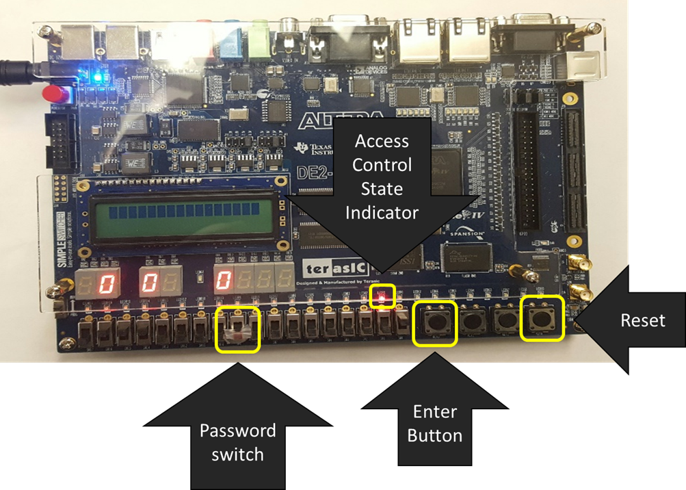Access control
   2. 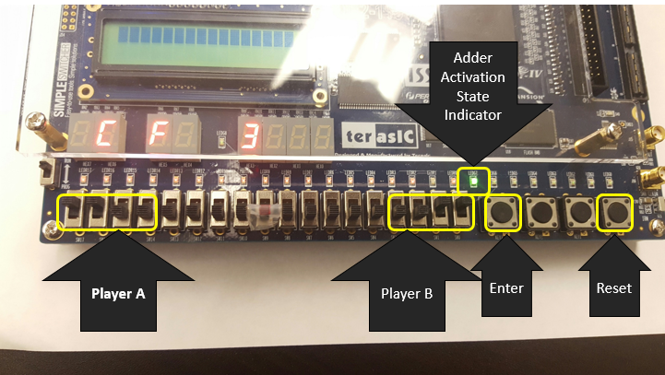Adder State
2. Password Guide
   1. The password is 010011 and you must input as LSB 1st bit. So you would enter 1 then 1..0..0..1..0. and every time you toggle, you must press enter button to change the state.